# ACTIVITIES

EXERCICE 1:Ri

|  |  |
| --- | --- |
| Objective | Take all the apples. |
| Maximum number of instructions | 8 |
| Allowed instructions | GO-UP GO-DOWN GO-LEFT GO-RIGHT PICK-UP REPEAT N-TIME WHILE IF |
| Allowed conditions | <HAS APPLE> |

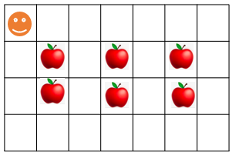

Answer:

Repeat 3-Time

Go Right

Repeat 2-Time

Go Down

Pick up

Go Right

Repeat 2-Time

Go up

EXERCICE 2:

|  |  |
| --- | --- |
| Objective | Bring all apples to their respective green box. |
| Maximum number of instructions | 10 |
| Allowed instructions | GO-UP GO-DOWN GO-LEFT GO-RIGHT PICK-UP DROP REPEAT N-TIME WHILE IF |
| Allowed conditions | <HAS APPLE> |

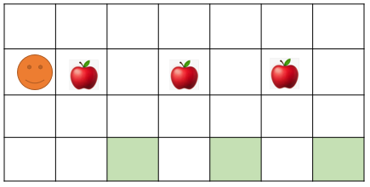

Repeat 3-Time

Go Right

Pick up

Repeat 3-Time

Go Down

Go Right

Drop

Repeat 3-Time

Go up

Answer:

EXERCICE 3:

|  |  |
| --- | --- |
| Objective | Pick up all apple and stop at the flag!! |
| Maximum number of instructions | 6 |
| Allowed instructions | GO-UP GO-DOWN GO-LEFT GO-RIGHT PICK-UP IF REPEAT N-TIME WHILE |
| Allowed conditions | <HAS APPLE> <HAS FLAG> <HAS **NO** FLAG> |

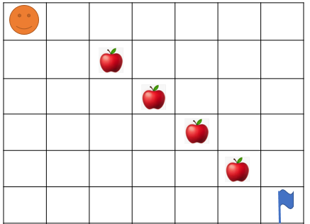

Repeat 5-Time

Go Right

Pick up

Go Down

Go Right

Answer:

EXERCICE 4:

What happen at the end?

* How many carrots Jack eats ?
* How many bananas Jack eats?
* Where will be Jack at the end?















EXERCICE 5:

|  |  |
| --- | --- |
| Objective | Bring all apple to green box and stop at the flag!!  WARNING : you program must work for the 2 cases !!! |
| Maximum number of instructions | 10 |
| Allowed instructions | GO-UP GO-DOWN GO-LEFT GO-RIGHT PICK-UP DROP IF REPEAT N-TIME WHILE |
| Allowed conditions | <HAS APPLE> <HAS CELL DOWN>  <HAS FLAG> <HAS **NO** FLAG> |

Case1: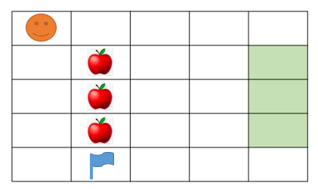

=

Case 2: 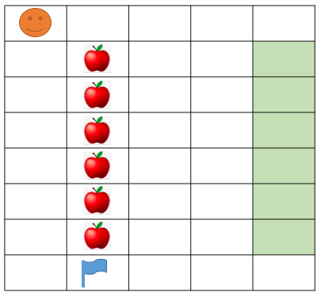



Go Right

While

Go Down

Pick up

Repeat 3-Time

Go Right

Drop

Repeat 3-Time

Go Left

Go Down

Answer:

EXERCICE 6:

|  |  |
| --- | --- |
| Objective | Take all the apple to green box  WARNING: you program must work for the 2 cases!!! |
| Maximum number of instructions | 15 |
| Allowed instructions | GO-UP GO-DOWN GO-LEFT GO-RIGHT PICK-UP DROP IF REPEAT N-TIME WHILE |
| Allowed conditions | <HAS APPLE> <HAS CELL ON RIGHT>  <HAS CELL ON LEFT> |



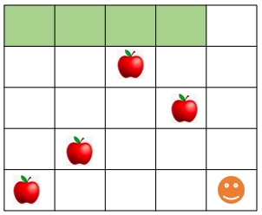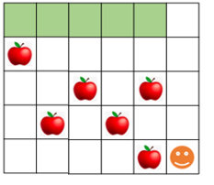

While

Go Left

Pick up

Repeat 4-Time

Go up

Pick up

Drop

Repeat 5-Time

Go Down

Answer:

EXERCICE 7:

|  |  |
| --- | --- |
| Objective | Take all the apple |
| Maximum number of instructions | 8 |
| Allowed instructions | GO-UP GO-DOWN GO-LEFT GO-RIGHT PICK-UP DROP  IF  REPEAT N-TIME WHILE |

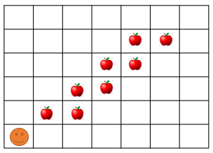

Answer:

Repeat 5-Time

Go Right

Pick up

Go up

Pick up

EXERCICE 8:

|  |  |
| --- | --- |
| Objective | Take all the apple and go to the green cell |
| Maximum number of instructions | 11 |
| Allowed instructions | GO-UP GO-DOWN GO-RIGHT PICK-UP  IF  REPEAT N-TIME WHILE |

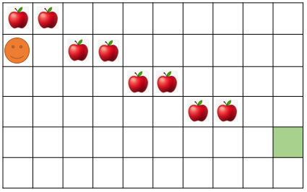

Answer:

Go up

Repeat 4-Time

Repeat 2-Time

Go Right

Pick up

Go Down

Go Right

Go Right

Drop

EXERCICE 9:

|  |  |
| --- | --- |
| Objective | Bring all apples put in the black cell and go to the green cell.  **Note**: your program must work for the 2 cases!!! |
| Maximum number of instructions | 10 |
| Allowed instructions | GO-UP GO-DOWN DROP GO-RIGHT PICK-UP  IF  REPEAT N-TIME WHILE |
| Allowed conditions | <HAS APPLE> <HAS CELL ON RIGHT>  <HAS CELL ON LEFT> <HAS CELL ON UP> |



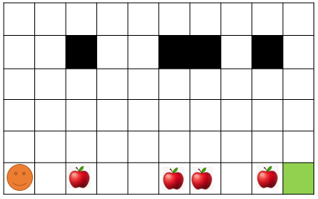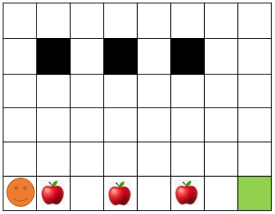

Answer:

While

Go Right

Repeat 4-Time

Go up

Pick up

Drop

Repeat 5-Time

Go Down

Go Right